**Monitoring Report**

**Template**

**Project Information**

|  |  |
| --- | --- |
| **Project Name** | **LIFE LOOP – Energy Communities – Local Ownership of Power** |
| **Grant Agreement** | **101077085** |
| **Project Duration** | **2022-2025** |
| **Project Coordinator** | **Energy Cities** |
| **Working Package**  **Deliverable**  **Responsible Partner** | **WP5**  **D5.2 Set of Templates**  **ELECTRA Energy Cooperative** |

**Disclaimer**

The sole responsibility of this publication lies with the authors and reflects only the authors’ view. Views and opinions expressed do not necessarily reflect those of the European Commission or CINEA. Neither the European Union nor the granting authority can be held responsible for them.

The LIFE LOOP Consortium as a whole nor any individual party, does not offer any assurance that the information presented in this document is suitable for immediate use and will accept no liability for any loss or damage experienced by any person and/or entity using this information.

Table of Contents

Introductory Remarks 3

How to use this Template 4

Monitoring Report -Introductory Information 5

Executive Summary 6

Purpose of the LIFE LOOP programme and the role of your initiative into the programme 6

Key Progress Points 6

Challenges and Issues during the Reporting Period 6

Community Energy Roadmap – Overview 7

Community Energy Roadmap – Your Strategic Plan’s Description 7

Geographic Coverage and Target Beneficiaries 7

Community Energy Roadmap – Your Strategic Plan’s Timeline 7

Objectives 7

Implementation Progress 9

Action Plan 9

Output Indicators 10

Challenges and Mitigation Measures 11

Lessons Learned 12

Key Insights: 12

Recommendations: 12

Next Steps 12

# Introductory Remarks

A key element of the LIFE LOOP project is the development of the Community Energy Roadmaps that the pilots *(Minoan Energy Community - Greece, City of Zagreb - Croatia, Municipality of Bistrita - Romania*) satellites and associated partners have been developing in parallel with the community energy workshops and with the support of the task forces (Electra in Crete; REGEA and ZEZ in Zagreb; Cooperativa de Energie in Bistrita) led by REScoop.eu and overall facilitated by Energy Cities (D2.4)**.**

Based on the aforementioned, it becomes necessary to record and monitor the specific goals and actions of the pilots outlined in the respective Community Energy Roadmaps, which will collectively lead to the achievement of all the LIFE LOOP project goals.

Thus, to facilitate the recording and monitoring of the implementation of the goals and actions set by the program's partners in the relevant Community Energy Roadmaps, a template for monitoring and reporting the implementation of the individual Community Energy Roadmaps was created within the framework of Work Package 5, and specifically as part of the Set of Templates (D5.2) managed by the project partners.

The development of this reporting template is based **on two key elements** that play a crucial role in the documentation and design of the monitoring report. The first element is the goals that the initiative or partner has committed to or aims to achieve, which essentially represent the KPIs (Key Performance Indicators) of the programme. Equally important is the second element: the specific actions outlined in the community energy roadmap (specifically into the Action Plan), through which the goals will be realized. Therefore, based on these two elements, a framework is developed for recording and monitoring the implementation of the goals of each initiative or pilot.

Moreover, as monitoring is an important part of the learning process, all the steps of the roadmap should be monitored and evaluated at frequent intervals. This way, the pilots and the rest of the partners will ensure that the information is updated regularly, all stakeholders are kept informed and on board, that adjustment of strategies/actions corrects for or makes up for deviations or shortfalls, that the progress is recorded, and the successes are celebrated!

Finally, this template for monitoring the implementation of a roadmap can also be used by any Energy Community, citizen-led initiative, and Municipality that have developed their strategic plan to implement community energy projects and relevant targets.

|  |
| --- |
| How to use this Template The following template is meant to serve as **guide** and to set the core points of your monitoring plan. The authors can tailor the following template to fit the specific needs and characteristics of their strategic community energy plan. Therefore, they will need to fill in the fields in **red**, where the description of completion is provided. The fields written in *[grey italics]* serve as guidance on how to fill in the monitoring report. Upon completion, please remove the text written in *[grey italics].*  Please note that the monitoring report is **a necessary and integral part of any strategic plan,** as only through tracking progress can we see how close we are to achieving our goals, where delays and difficulties are observed, and how we can overcome them once identified. |

|  |
| --- |
| Monitoring Report -Introductory Information *[Insert the following information]*  ***Programme Title:***  ***Initiative-Organisation:***  ***Prepared by:***  ***Position:***  ***Contact Information:***  ***Date of Monitoring Report:***  ***Reporting Period:***  ***[Insert your logo]*** |

# Executive Summary

### Purpose of the LIFE LOOP programme and the role of your initiative into the programme

*[Briefly describe the overall goals and objectives of the program, and emphasize the role your initiative plays in the realization of the goals of the entire project.]*

### Key Progress Points

*[Summarize the major tasks and milestones achieved during the reporting period.]*

### Challenges and Issues during the Reporting Period

*[Highlight any significant challenges or issues encountered and their potential impact on your Community Energy Roadmap]*

|  |  |
| --- | --- |
| Challenge | Potential Impact |
|  |  |
|  |  |
|  |  |
|  |  |
|  |  |
|  |  |

# Community Energy Roadmap – Overview

### Community Energy Roadmap – Your Strategic Plan’s Description

*[Provide a brief description of your Strategic Plan-Roadmap, including its scope, main objectives, and expected outcomes.]*

### Geographic Coverage and Target Beneficiaries

*[Specify the regions or areas where your Roadmap is being implemented. Provide a brief description of the target groups included into your strategic plan, and their connection with your initiative – organisation.]*

### Community Energy Roadmap – Your Strategic Plan’s Timeline

*[Provide a brief description of your Strategic Plan-Roadmap’s timeline]*

### Objectives

*[Provide a detailed description of your roadmap’s objectives in conjunction with the targets set in the context of the LIFE LOOP project.*

*In this direction, the following table will facilitate the process for your organization as it presents the overall objectives of the LIFE LOOP project.]*

*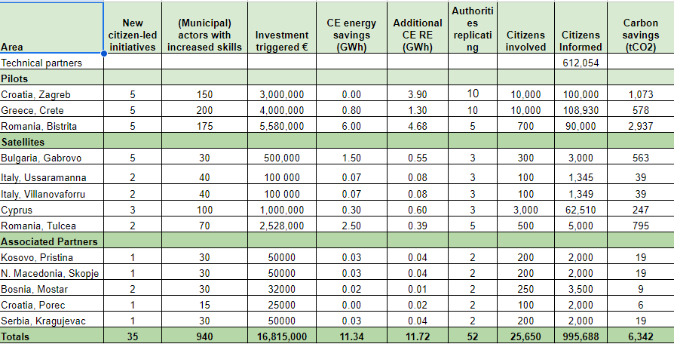Table 1: LIFE LOOP objectives during its the implementation period*

*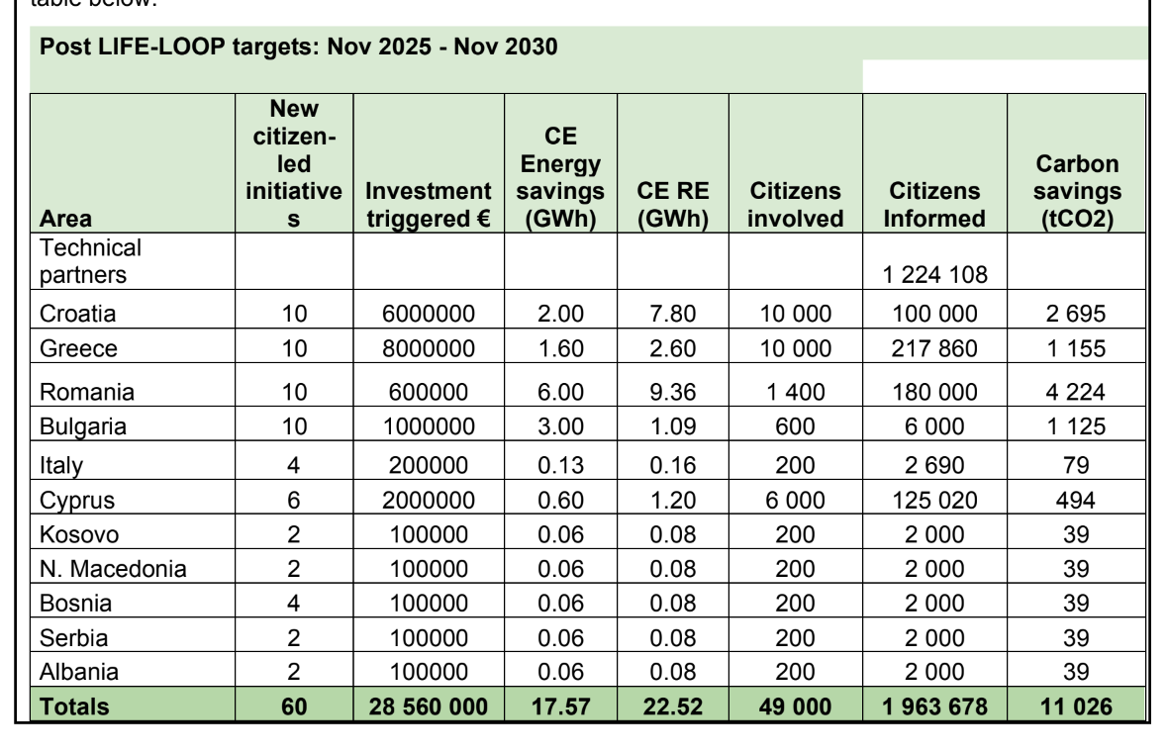Table 2: Post LIFE LOOP objectives: Period Nov 2025 – Nov 2030*

# Implementation Progress

### Action Plan

*[List and describe the activities carried out during the reporting period.]*

|  |  |  |  |  |
| --- | --- | --- | --- | --- |
| Action | Milestone | Timetable | Status | Remarks  *[Refer to any related challenges -unexpected events]* |
|  |  |  |  |  |
|  |  |  |  |  |
|  |  |  |  |  |
|  |  |  |  |  |
|  |  |  |  |  |
|  |  |  |  |  |
|  |  |  |  |  |
|  |  |  |  |  |
|  |  |  |  |  |
|  |  |  |  |  |
|  |  |  |  |  |
|  |  |  |  |  |

### Output Indicators

*[List and present the key output indicators, their status, and the respective targets in reference to the above actions, in order to record and monitor your progress in relation to your specific objectives (KPIs) set in the context of LIFE LOOP project.]*

|  |  |  |  |  |
| --- | --- | --- | --- | --- |
| Related Action | Output Indicator | Objective | Status (Completion of the objective) | Remarks |
|  |  |  |  |  |
|  |  |  |  |  |
|  |  |  |  |  |
|  |  |  |  |  |
|  |  |  |  |  |
|  |  |  |  |  |
|  |  |  |  |  |
|  |  |  |  |  |
|  |  |  |  |  |
|  |  |  |  |  |
|  |  |  |  |  |
|  |  |  |  |  |

# Challenges and Mitigation Measures

*[Describe the challenges faced during the implementation period in relation to the respective actions, and outline the mitigation measures proposed/taken to address these challenges.]*

|  |  |  |  |
| --- | --- | --- | --- |
| Related Action | Challenge | Mitigation Measures | Remarks |
|  |  |  |  |
|  |  |  |  |
|  |  |  |  |
|  |  |  |  |
|  |  |  |  |
|  |  |  |  |
|  |  |  |  |
|  |  |  |  |
|  |  |  |  |
|  |  |  |  |
|  |  |  |  |
|  |  |  |  |

# Lessons Learned

### Key Insights:

*[Highlight any lessons learned from the implementation process.]*

### Recommendations:

*[Provide recommendations for improving implementation of your action plan.]*

# Next Steps

*[Outline the activities planned for the next reporting period and identify the relevant key milestones for the upcoming period.]*

|  |  |  |  |
| --- | --- | --- | --- |
| Next Action | Milestone | Timetable | Responsible |
|  |  |  |  |
|  |  |  |  |
|  |  |  |  |
|  |  |  |  |
|  |  |  |  |
|  |  |  |  |
|  |  |  |  |
|  |  |  |  |
|  |  |  |  |
|  |  |  |  |
|  |  |  |  |
|  |  |  |  |