

**Project Information**

| **Project Name** | **LIFE LOOP – Energy Communities – Local Ownership of Power** |
| --- | --- |
| **Grant Agreement** | **101077085** |
| **Project Duration** | **2022-2025** |
| **Project Coordinator** | **Energy Cities** |
| **Working Package**  **Deliverable**  **Responsible Partner** | **WP5**  **D5.2 Set of Templates**  **ELECTRA Energy Cooperative** |

**Disclaimer**

The sole responsibility of this publication lies with the authors and reflects only the authors’ view. Views and opinions expressed do not necessarily reflect those of the European Commission or CINEA. Neither the European Union nor the granting authority can be held responsible for them.

The LIFE LOOP Consortium as a whole nor any individual party, does not offer any assurance that the information presented in this document is suitable for immediate use and will accept no liability for any loss or damage experienced by any person and/or entity using this information.

**Table of Contents**

Introductory Remarks 0

How to use this template 1

Part I: Stakeholder Mapping 2

Understanding Stakeholders 2

Energy Communities Stakeholders-Overview 2

Map 1: Overview of Internal and External Stakeholders of an Energy Communities 3

Analysis of Stakeholders 4

Internal Stakeholders 4

Diagram 1: Membership 4

Map 2: Map of Internal Stakeholders 5

Table 1: Analysis of Internal Stakeholders 5

External Stakeholders 6

Map 3: Map of External Stakeholders 7

Table 2: Analysis of External Stakeholders 8

The Municipality as a Stakeholder 9

Graph 1: Means of Cooperation with your Local Municipality 9

Diagram 2: Identifying the Common Ground with your Municipality 10

Table 3: Building Synergies with your Municipality 10

# Introductory Remarks

Energy Communities are **based on their people** who shape their collaborative relationships toward a common goal. Therefore, who will participate in an energy community is crucial to achieving its vision. At the same time, Energy Communities act in a social, economic and, administrative context composed of a variety of stakeholders that can either be its potential members or stakeholders with whom they will be obliged to cooperate to fulfill their objectives.

A key stakeholder is the **local government**–as the closest body of the national government to local citizens- which can play an essential role in supporting the development of community energy projects. Local governments from their position, have the opportunity to actively support citizen engagement in the energy transition, and ensure that the local communities are developing in all respects toward a more sustainable, inclusive, and democratic energy future. Consequently, in the following guide, particular and extensive reference is made to local public authorities.

This document aims to provide Energy Communities with **methods to identify** all the stakeholders, whether internal or external, who have the power to either influence the course of an Energy Community. After being identified by the Energy Community, their analysis should be conducted to determine their role and overall position regarding the activities of the Energy Community.

Admittedly, an Energy Community **needs allies** to be able to realize its common vision. Therefore, the building of communication and cooperation bridges with external partners who are active in the administrative, technical, social, academic, or commercial field is crucial.

Moreover, the objective of this guide is to provide ideas and offer a potential structure of the stakeholder mapping process of your Energy Community, with the aim of facilitating the further democratic energy transition of your local community, which also assists and promotes **the participation of people of all genders on equal terms.**

The **target audience** of this guide is citizens and municipalities interested in establishing an Energy Community. For the purpose of this exercise, we will assume that an Energy Community is in its early stage of development. However, it is essential to note that the actions outlined in this guide are **dynamic,** so it will be useful for you to **regularly review** your plan.This way, your Energy Community remains adaptable to the changing circumstances and can effectively engage with both existing and emerging stakeholders. It is also essential to **customize** the following plan to **align** with the specific needs and vision of your Energy Community.

*“As your Energy Community evolves, so will your stakeholder map”*

| How to use this template This document is meant to serve as a **guide**. Readers and users can **tailor** the following stakeholder mapping process **to the specific needs and situation of their local community**.  Regarding the stakeholder mapping process, mainly graphs, tables and their explanation are provided to facilitate the identification and analysis of the relevant stakeholders. Based on these, you can design **your own stakeholder map** to **meet your local needs**, and reflect the local situation and the local key stakeholders.  Once you have identified and analysed the relevant local stakeholders, the **next step** is the stakeholder engagement plan, where you will need to design an engagement plan setting out how you can involve them in the development of your Energy Community.    *The Stakeholder Engagement Plan can be found in* ***Part II*** *of the Stakeholder Mapping and Engagement Plan Guide.* |
| --- |

# Part I: Stakeholder Mapping

## Understanding Stakeholders

To set the foundation for the following exercise, it is useful to comprehend the **definition of a stakeholder.** In general, stakeholders are individuals or legal entities who can externally influence or are actively involved in a project. Various theories exist for categorizing stakeholders, including classifications based on their level of interest and influence, functionality, enabling role, and more.

In this guide, we will utilize a stakeholder categorization model based on the stakeholder’s **core relationship with a project**. Therefore, stakeholders will be classified as **internal,** i.e. those actively involved in the community energy project, e.g. members, and **external**, i.e. those who are not members of the Energy Community, but somehow can influence its development.

***“Internal and external stakeholders both play an equally vital role”***

Although, it could be said that the emphasis should be placed on the internal stakeholders of the Energy Community, i.e. the members, as they have a direct influence on decision-making and shaping the direction of the initiative, the external stakeholders **play an equally vital role** in implementing and developing a project. An Energy Community admittedly operates within the legal framework established by the national government, and there are administrative procedures that must be followed to set up a legal entity, while the construction of a renewable energy project and its connection to the electricity grid require the support and assistance of experienced engineers and DSO, respectively.

## Energy Communities Stakeholders-Overview

As mentioned above, the success and sustainability of a project are influenced by internal and external stakeholders. The same applies to community energy projects and initiatives. Therefore, it would be highly beneficial helpful to **discover and map the ecosystem** of local stakeholders at the beginning of your initiative.

By mapping the local stakeholders, you will be able to identify which stakeholders could potentially join your Energy Community, based on the **requirements set by you**, such as the shared vision for the protection of the local environment, gender justice, and addressing climate change and energy poverty. At the same time, you will be able to recognize which stakeholders you will need to work with to realize your vision. Therefore, at this stage, it is important to map the ecosystem of local stakeholders to identify who they are, and determine their potential role in your Energy Community. This mapping exercise will help you identify potential members of your Energy Community, as well as external actors who may provide necessary services or become potential partners to help you achieve your goals.

Keep in mind that stakeholder mapping is a **dynamic process,** as the list of potential partners is likely to expand as your Energy Community grows and evolves over time, therefore, you should regularly review this map.

The map below presents an example of stakeholder mapping by categorizing stakeholders into internal and external actors. You can utilize this example as a starting point to create your own map, by asking the contribution of your whole group, allowing each member to share their perspective and insights regarding the identified stakeholders. This collaborative effort will result in a more comprehensive and detailed representation of the stakeholder landscape.

### Map 1: Overview of Internal and External Stakeholders of an Energy Communities

## Analysis of Stakeholders

Once you have identified the local stakeholders, you can proceed with the stakeholder analysis phase.

This step will enable you to gain a **deeper and more comprehensive understanding** of the role and significance of each stakeholder in relation to your Energy Community and your vision. By conducting this analysis, you will be able to assess factors such as their role, level of influence, interests, needs, and potential synergies. This information will guide you in effectively engaging with each stakeholder, aligning their interests with your Energy Community’s goals, and fostering cooperation.

### Internal Stakeholders

Internal stakeholders are the members of the Energy Community. These individuals or legal entities have a direct relationship with the Energy Community. Members have equal rights and hold a voting right in decision-making processes during the General Assembly. Additionally, membership entails co-ownership of the cooperative which is achieved through the acquisition of a share of the cooperative capital, and fosters a sense of responsibility among members to actively contribute to the community.

### Diagram 1: Membership



The selection of internal members is of utmost importance, as they will constitute the **driving force** of the Energy Community and will shape its direction and activities. Hence, the initial step is to identify local stakeholders who could potentially become members of the Energy Community. Concurrently, you can integrate this identification process with **a timeline outlining** when you plan to reach out to each stakeholder. The following map presents an example of the potential members of your Energy Community at various stages of its development.

### Map 2: Map of Internal Stakeholders

The table below offers an example of organising the stakeholder analysis. As with the identification process, this can be a collaborative exercise for your Energy Community, allowing each member to contribute their unique perspective. Additionally, it is crucial to integrate a **gender perspective** into your team by promoting and supporting the participation of individuals of all genders. This will help create a balanced team and foster a shared mindset of equality.

### Table 1: Analysis of Internal Stakeholders

| **Internal Stakeholder**  **Key Contact** | **Role/Position** | **Level of Influence** | **Interests/Needs**  **Common Ground** | **Potential Contribution** |
| --- | --- | --- | --- | --- |
| **Citizens** |  |  |  |  |
| **Local Government** |  |  |  |  |
| **Local Enterprises** |  |  |  |  |
| **Organisations**  **Institutions** |  |  |  |  |

### External Stakeholders

External stakeholders are individuals or legal entities that exist outside of the Energy Community, but are affected by or have an impact on its operations. These stakeholders can exert **varying levels of influence** on the activities of the Energy Community and may hold **different interess and priorities**.

Concretely, the analysis of external stakeholders can be crucial for the success of your project in the following ways:

* **Understanding the Energy Community’s environment**: Analysing external stakeholders can provide insight into the wider environment surrounding the project. This can include identifying political, social, economic, and technological factors that can influence your project. Concurrently, this process allows you to effectively engage with stakeholders who have the potential to impact your project positively or negatively.
* **Building support and partnerships:** By analysing stakeholders who have a vested interest in the project's success, you can create alliances with them. This can include local community members, local businesses, and local government representatives. There are key supporters who can provide valuable resources, expertise, or advocacy that can contribute to the success of your community energy project.
* **Mitigating risks:** Identifying and analysing stakeholders who may have concerns or objections to the project can help you anticipate potential risks and develop strategies to mitigate them. This allows you to proactively address concerns or project failure due to unexpected obstacles.
* **Enhancing communication and resources**: Stakeholder analysis helps you tailor your communication strategies to effectively reach and involve external stakeholders. By engaging with external stakeholders, you can also utilize the valuable resources, knowledge, or expertise that can support your community energy project’s implementation.

Overall, the analysis of external stakeholders provides insights and opportunities for collaboration, support, and effective stakeholder management, while also preparing you for potential risks associated with external stakeholders.

The following map serves as an illustration of the external stakeholders.

### Map 3: Map of External Stakeholders

The table below provides an example of how to structure the analysis process. Based on this, you can develop your **own analysis system**, which can be an exercise for your team. By having each member contribute their perspective and insights on each identified stakeholder, **Table 2: Analysis of External Stakeholders**

a more complete and comprehensive view can be achieved.

### 

| **External Stakeholder**  **Key Contacts** | **Role**  **Position** | **Level of Influence** | **Interests/Needs**  **Common Ground** | **Potential Contribution** | **Risks related to your cooperation** |
| --- | --- | --- | --- | --- | --- |
| **Local Citizens** |  |  |  |  |  |
| **Local Enterprises** |  |  |  |  |  |
| **Organisations**  **Institutions** |  |  |  |  |  |
| **Local Government** |  |  |  |  |  |
| **Regional Government** |  |  |  |  |  |
| **National Governement** |  |  |  |  |  |
| **DSO** |  |  |  |  |  |
| **Energy Suppliers** |  |  |  |  |  |
| **Aggregators** |  |  |  |  |  |
| **Legal & Technical Support** |  |  |  |  |  |
| **Community Energy Network** |  |  |  |  |  |

## The Municipality as a Stakeholder

As mentioned earlier, one of the main objectives of this guide is to highlight **the role of local governments** in development of your community energy project. You may have noticed that the local government appears in both the internal and external stakeholder categories. This is because local authorities play a crucial role in promoting the growth of energy communities in Europe, either through direct or indirect means.

Therefore, there are two categories of municipal support mechanisms:

1. **Direct support mechanisms:** These encompass all the ways in which local authorities can directly engage and cooperate with local community energy projects.
2. **Indirect support mechanisms**: These aim to foster the empowerment of local citizens by creating an enabling framework, and providing Energy Communities and citizen-led initiatives with equal opportunities to participate in local economic activities.[1]

The following graph shows cases of municipal support to Energy Communities.

### Graph 1: Means of Cooperation with your Local Municipality

### Diagram 2: Identifying the Common Ground with your Municipality

During the analysis of the local government, you will realize that your Energy Community and the local municipality **share a lot in common**, as you operate in the same geographical area, address the same local needs, and you are social and **community-driven** rather than profit-oriented. To establish common ground and prepare for a discussion with the local government, it would be helpful to create a list of potential shared goals between your Energy Community and your municipality. You can consult the municipality’s [**local action plan**](https://eu-mayors.ec.europa.eu/en/action_plan_list), and explore public objectives and actions related to renewable energy, energy efficiency, environmental targets, and economic development.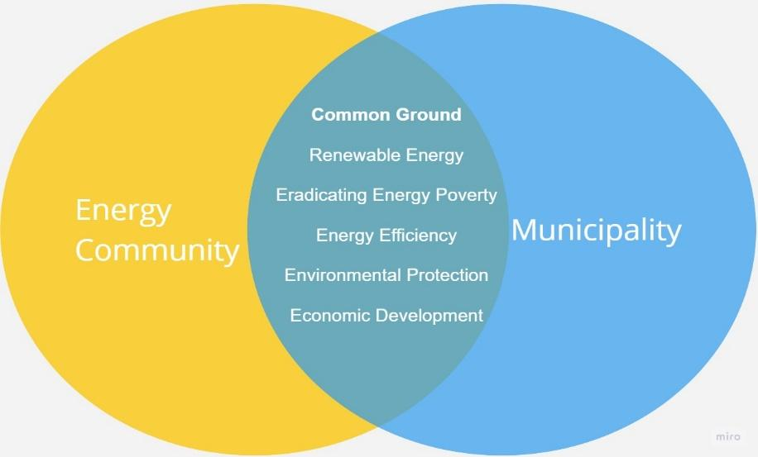

A **stable and productive** collaboration between Energy Communities and local public authorities can yield mutual benefits, given their shared interests. Whether you plan to engage directly or indirectly with your local government, you could identify relevant energy, environmental, and financial actions to contribute, provided they align with your shared goals.

The table below illustrates an example of how to identify specific ways of collaborating with your municipality.

### Table 3: Building Synergies with your Municipality

| **Municipality** | | **Energy Community** | |
| --- | --- | --- | --- |
| **Objectives** | **Cooperation Possibility** | | **Objectives** |
| **Local Electricity Production from RES** |  | | **Developing a Renewable Energy Technologies based on the Local Potential** |
| **Energy Efficiency in Public**  **Buildings and Equipment** |  | | **Energy Efficiency Measures for the Members** |
| **Alleviation of**  **Energy Poverty** |  | | **Identifying and Including Households Facing Energy Poverty in the VNM project free of charge** |
| **Creation of New Jobs** |  | | **Providing Training and Education** |
| **Other** |  | | **Other** |
|  |  | |  |
|  |  | |  |
|  |  | |  |
|  |  | |  |

*The* ***Stakeholder Engagement Plan*** *can be found in Part II of the Stakeholder Mapping and Engagement Plan Guide.*



*You can continue your search for more guides, templates, and reports by exploring the available resources* [*here*](https://energy-cities.eu/project/lifeloop-resources/)*!*

*“It’s time to bring even more local governments, citizens and SMEs to the energy community movement! It’s time to make them the true drivers of our society.”*

*Visit us* [*here*](https://energy-cities.eu/project/lifeloop/)*!*

1. Stanislas d’Herbemont et al., “The Municipal Guide”, (D4.4 Stakeholder Guidance, WP4, Compile Project), 13.