
Project Information

Project Name | LIFE LOOP – Energy Communities – Local Ownership of Power
Grant Agreement | 101077085
Project Duration | 2022-2025
Project Coordinator | Energy Cities
Working Package  Deliverable  Responsible Partner | WP5  D5.2 Set of Templates  Electra Energy Cooperative

Disclaimer
The sole responsibility of this publication lies with the authors and reflects only the authors’ view. Views and opinions expressed do not necessarily reflect those of the European Commission or CINEA. Neither the European Union nor the granting authority can be held responsible for them.

The LIFE LOOP Consortium as a whole nor any individual party, does not offer any assurance that the information presented in this document is suitable for immediate use and will accept no liability for any loss or damage experienced by any person and/or entity using this information.

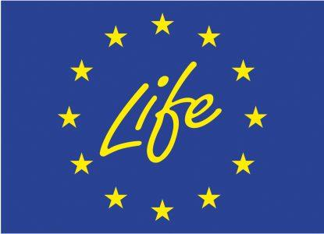 This project has received funding from the European Union’s LIFE programme under grant agreement No 101077085

Business Model Canvas – PPA between Energy Communities and Municipalities

Template

 |  |  | Designed for: |  |  |  | Business model |  |  | Date: |  | Version:
Business Model Canvas |  |  | Energy Communities |  |  |  | PPA: Energy Community –  Municipality
Key Partners | Key Activities |  |  | Value Propositions |  | Member Relationships |  |  |  | Member Segments
-Financial institutions (banks, credit unions, cooperative banks)  -Legal consultants  -Renewable energy equipment suppliers (EPC)  -Construction and engineering companies (EPC)  -Regulatory bodies and energy market operators  -Community organizations and stakeholders | -Developing and maintaining renewable energy installations (e.g., solar, wind)  -Negotiating and managing the PPA with the municipality  -Monitoring and optimizing energy production  -Engaging and mobilizing the community  -Securing financing and subsidies  -Complying with regulatory requirements |  |  | -Providing clean, renewable energy to the municipality  -Contributing to local sustainability and environmental goals  -Reducing electricity costs for the municipality  -Enhancing energy security and independence  -Creating local jobs and stimulating the local economy  -Fostering community engagement and ownership in renewable energy projects |  |  | -Transparent communication between the energy community and the municipality  -Regular updates and reporting on energy production and savings  -Collaborative planning and decision-making processes  -Long-term partnership and support  -Community outreach and engagement activities |  |  | -Municipal government (primary user/customer)  -Residents and businesses within the municipality (indirect beneficiaries)  -Community members participating in the energy project
 | Κey Resources |  |  |  |  |  | Channels |  |  | Environmental and social benefits
 | -Renewable energy installations (solar panels, wind turbines)  -Financial capital (grants, loans, community investments)  -Technical expertise (engineering, legal, financial)  -Community support and participation  -Technology for energy management and monitoring |  |  |  |  |  | -Direct negotiations and meetings with municipal officials  -Community meetings and public consultations  -Local media and newsletters  -Online platforms and social media  -Public reports and presentations |  |  | -CO2 emissions reduction  -Social impacts
Cost Structure  -Capital costs for renewable energy installations  -Operational and maintenance expenses  -Costs for community engagement and mobilization  -Administrative and legal costs for PPA management  -Costs associated with compliance and regulatory approvals |  | Revenue Streams  -Payments from the municipality for electricity generated  -Government grants and subsidies for renewable energy projects  -Community investments and membership fees  -Potential savings from reduced energy costs |  |  |  |  |  | Risks, Challenges and Barriers  -Short contract periods  -Grid congestion / unsuccessful permitting process  -High balancing costs  -Luck of human resources  -Unstable legal and regulatory framework  -Luck of funds/capital/financing resources  -Dysfunctional governance model / Inefficient internal relationships

